**Story:**

Auto house LTD. is a car retail seller company in Bangladesh. There are various kinds of cars from different regions all around the world. Vehicles are imported from many exporters. In their car showroom cars are sorted according to their body type, Brand, and their type. They keep track of sales and their customers. They give a car warranty and free services. Their management system is very simple but effective.

**Entities:**

**-Brand**

**-Body**

**-Exporter**

**-Vehicle Records**

**-Sale**

**-Customer**

**Attributes:**

**Brand(**brandName, region**)**

**Body(**bodyType**)**

**Exporte(**brandName,region,carName,vin,carMilage,carStickerPrice,carCondition,transactionID,exporterNAme**)**

**VehiclesRecords(**brandName,region,carName,vin,bodyType,year,engineCapacity,passengerCapacity,carType,available,quantity**)**

**Sale(**brandName,region,carName,vin,price,receiptID,sale date,delivery date**)**

**Customer(**customerNAme,customerNumber,carWarrenty,receiptID,totalServices**)**

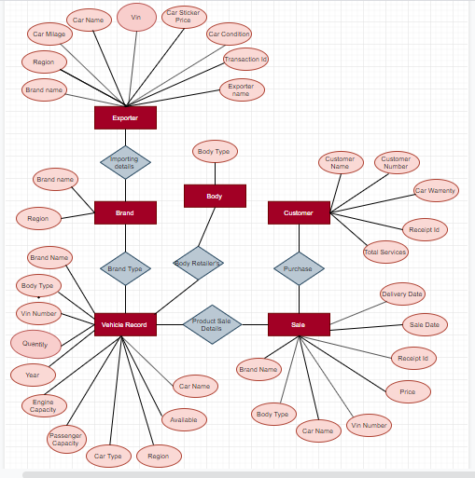

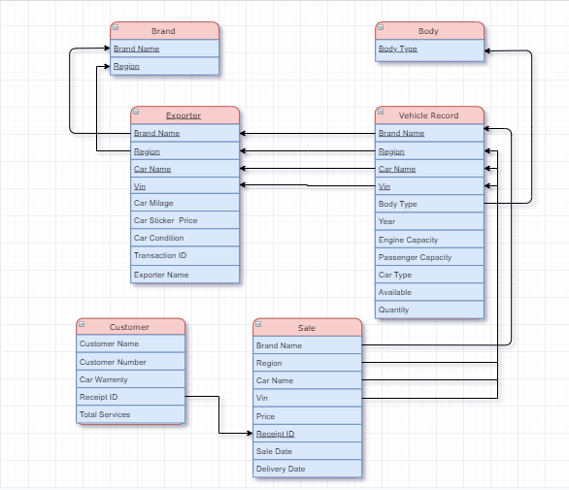

**Table creation code**

create database CarDB

go

use CarDB

go

create table Brand

(

brandName varchar(50),

region varchar(50),

primary key (brandName,region)

);

create table Body

(

bodyType varchar(50) primary key

);

create table Exporter

(

brandName varchar(50),

region varchar(50),

carName varchar(50),

vin int,

primary key(brandName,region,carName,vin),

carMilage int,

carStrickerPrice float,

carCondition varchar(50),

transactionID int,

exporterName varchar(50)

);

create table vehicleRecord

(

brandName varchar(50),

region varchar(50),

carName varchar(50),

vin int,

bodyType varchar(50),

yearr int,

engineCapacity float,

pessengerCapacity int,

carType varchar(50),

available varchar(50),

quantity int,

primary key (brandName,region,carName,vin),

foreign key (brandName,region,carName,vin) references Exporter,

foreign key(bodyType) references Body

);

create table Sale

(

brandName varchar(50),

region varchar(50),

carName varchar(50),

vin int,

price int,

receiptID int primary key,

saleDate varchar(50),

deliveryDate varchar(50)

foreign key (brandName,region,carName,vin) references vehicleRecord

);

create table Customer

(

customerName varchar(30),

customerNumber int,

carWarrenty int,

receiptID int,

totalServices int,

foreign key (receiptID ) references Sale

);

**Query:**

select avg(price) as avg_price_,brandName from Sale group by brandName

select * from Sale where price>6900000

select * from vehicleRecord where region='Germany' and engineCapacity>5.5

select distinct vehicleRecord.carName from vehicleRecord,Exporter where Exporter.carMilage<5000 and vehicleRecord.vin=Exporter.vin

select * from vehicleRecord where yearr>2017

select MIN(price) as min_price from Sale

select Max(price) as max_price from Sale

select Sum(price) as Total_sale from Sale

select count(*) as new_car_count from vehicleRecord where yearr>2017

select brandName,carName from vehicleRecord where region='Germany' and pessengerCapacity between 4 and 5

